Wireframe Document

Thyroid Detection

Revision Number: 1.0

Last date of revision:

Document Version Control

|  |  |  |  |
| --- | --- | --- | --- |
| Date Issued | version | Descrition | Author |
|  | 1.0 | First Version of Complete Wireframe Document | Ritik Bhambid |
|  |  |  |  |
|  |  |  |  |
|  |  |  |  |
|  |  |  |  |
|  |  |  |  |
|  |  |  |  |

Contents

Document Version Control……………………………………………………………………2

1 Home Page……………………………………………………………………………….….3

2 Retraining……………………………………………………………………………………4

Homepage

I have divided Thyroid Detection System Homepage into two sections : -

1. Custom File Predict
2. Default File Predict

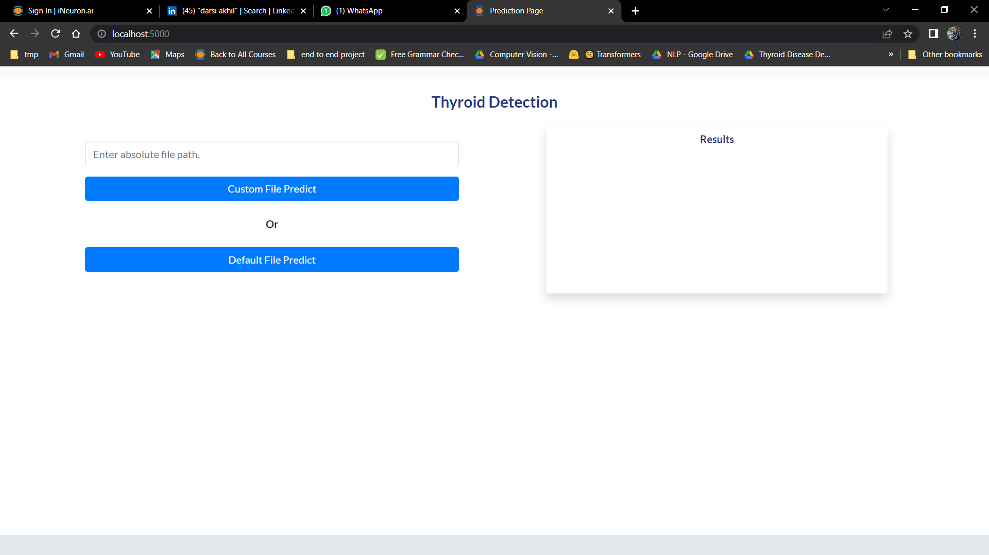

Retraining

Retraining happens through postman API via train route:

